**1 INTRODUCTION**

* 1. Overview

A business card typically includes the giver’s name, company or business and affiliation and contact information such as street addresses ,telephone number(s),fax number, e-mail addresses and website. Before the advent of electronic communication, business cards also included telex details.

* 1. Purpose

Business cards serve the key purpose of marketing your business and getting your key contact information into your client’s hands. All in a matter of seconds. Fundamental to the value of the business card , is its probability.

**Problem Definition &Design thinking**

2.1 Empathy map

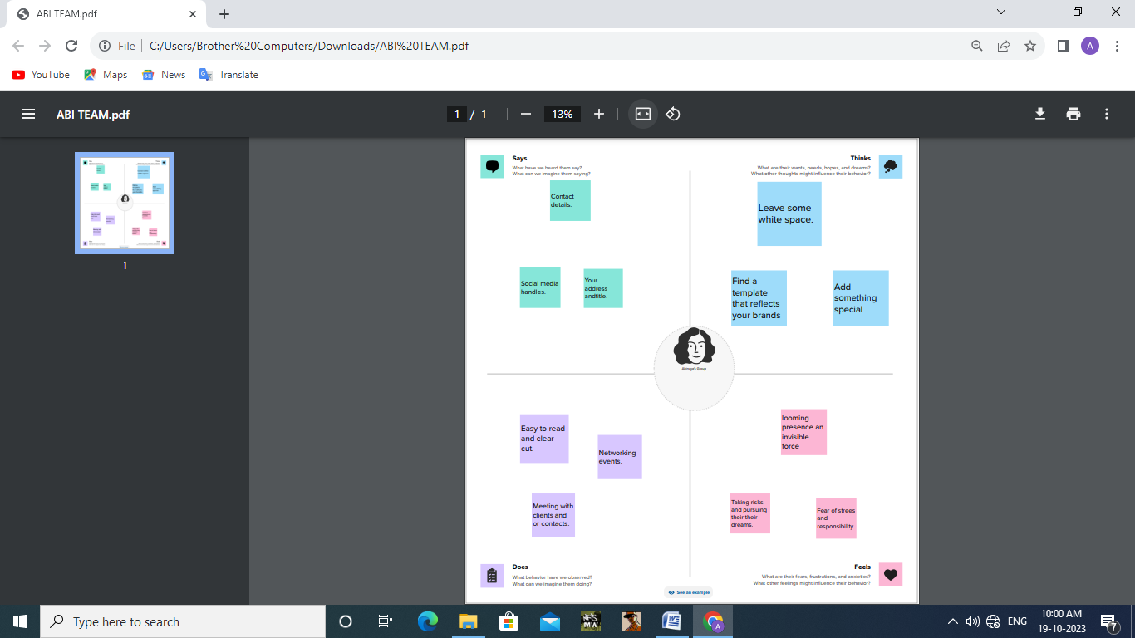

2.2 ideation & Brainstorming map

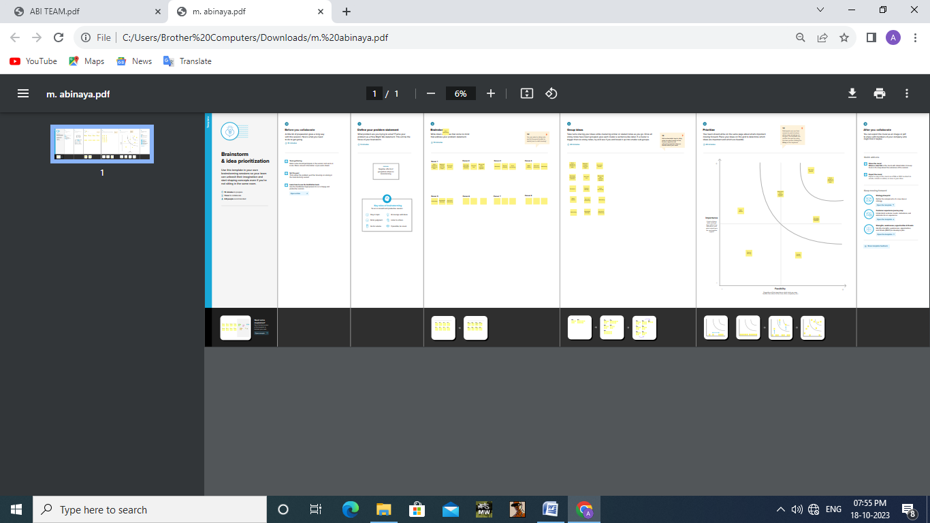

1. **RESULT**

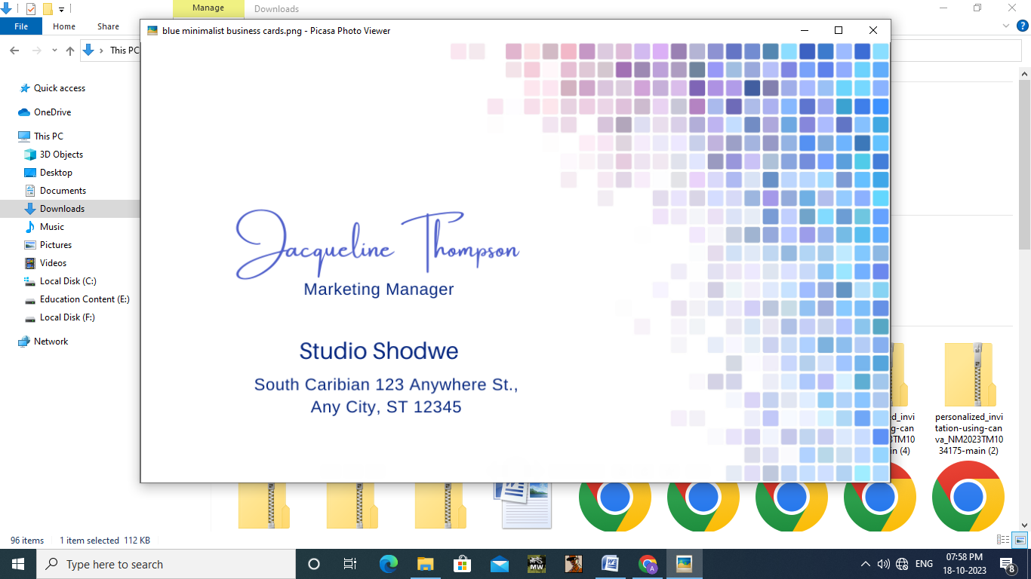

1. **ADVANTAGES & DISADVANTAGES**

Advantages

* It’s helpful for networking at trade shows and events.
* It helps to give your company identity
* It is a cheap form of marketing and advertising for your company

Disadvantages

* The cost to design and print. Creating a design that stands out and gets you noticed often requires help from a professional graphic designer.
* They need to be kept up-to –date.
* They have limited information.

1. **APPLICATION**

**H**osting key business informations ,such us your website, email and phone number,a business card encourages people to contact you ,visit your business and learn more about you.

1. **CONCLUSION**

Digital business cards offer a great way to save time and money while also helping to protect the environment.